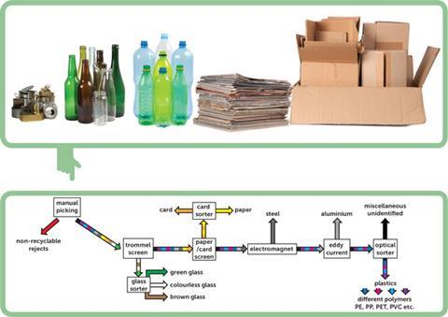

Specialised materials recovery facility used to sort between all the different types of rubbish and to differentiate between the various types of each material. This involves identification techniques, such as x-ray fluorescence (XRF) and rapid-scanning near infrared (NIR) spectroscopy, using reflected and/or transmitted light. These systems are integrated with computer-controlled mechanisms that physically separate each item once it has been identified.[1]

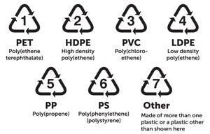

Types of recycling classification

Household:

* Green-recycling
* Brown-food and garden waste
* Black-General waste

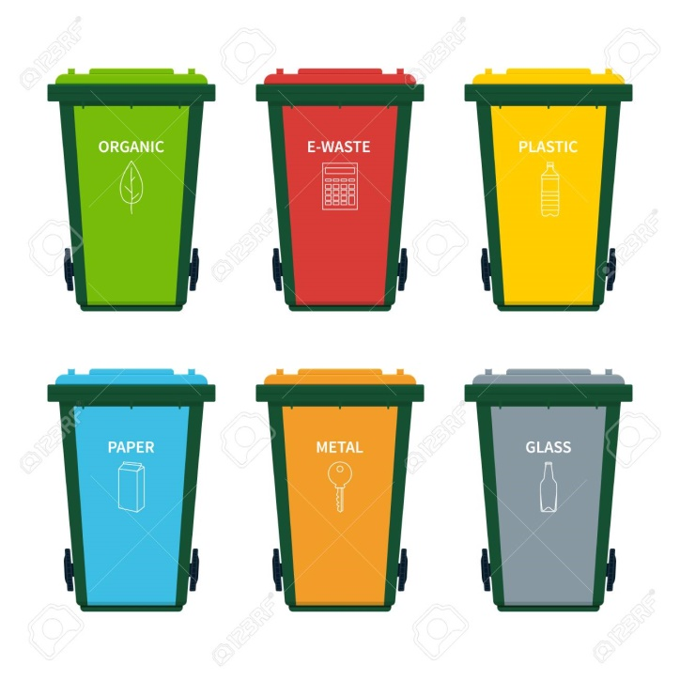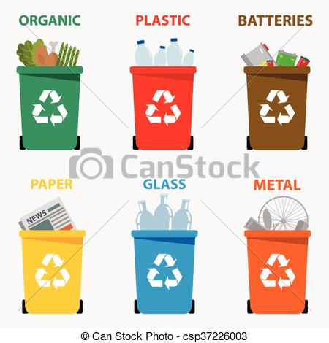

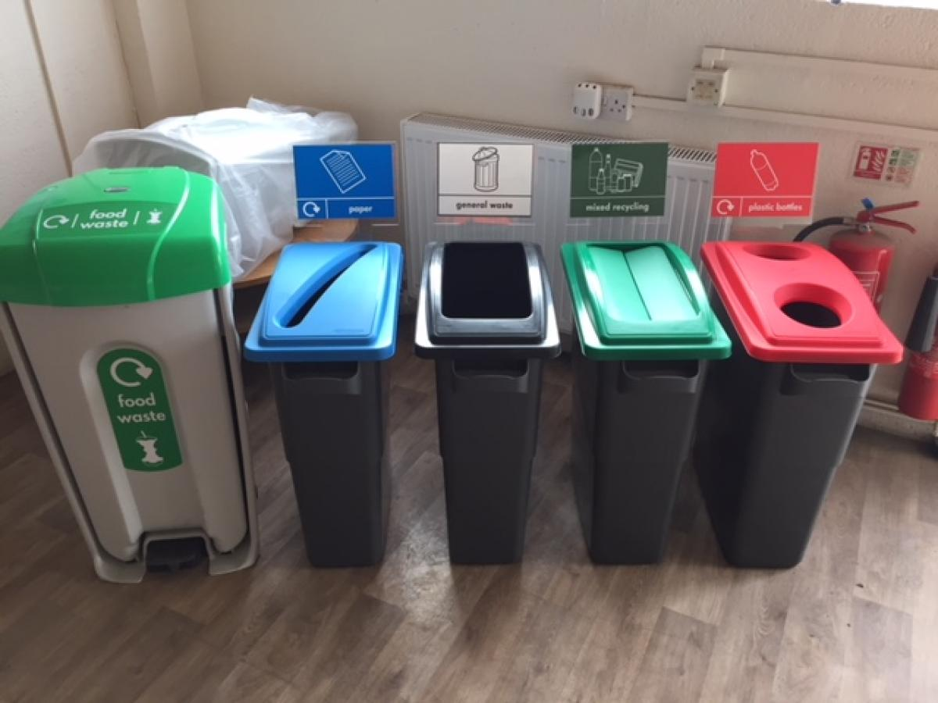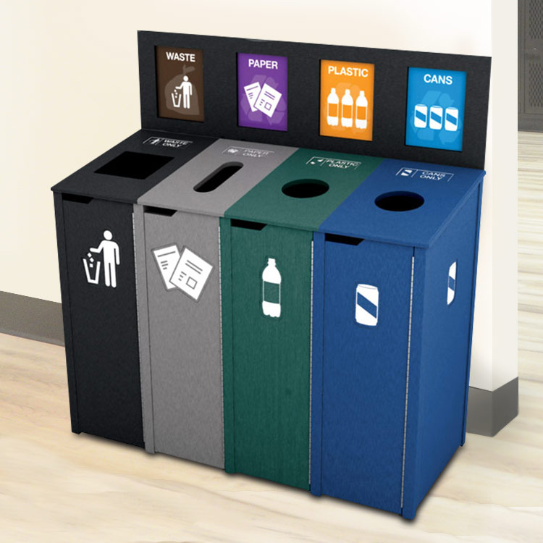

Aluminium

* Cans typically are 75% Aluminium or 25% steel[2]
* Sorted using an eddy current separator
* Good heat and electrical conductor
* Lightweight
* Good reflector of light
* Low density and melting point
* Non-magnetic[3]

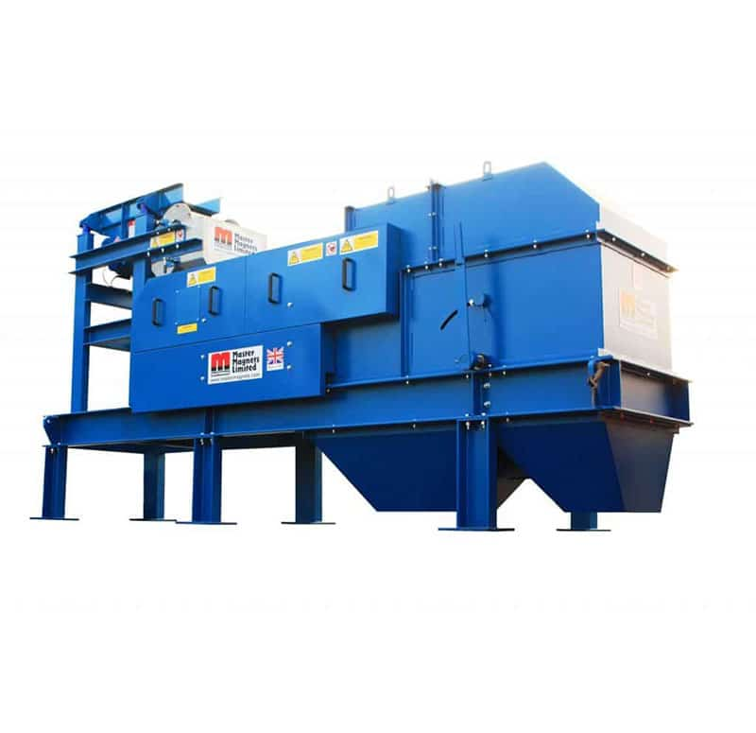

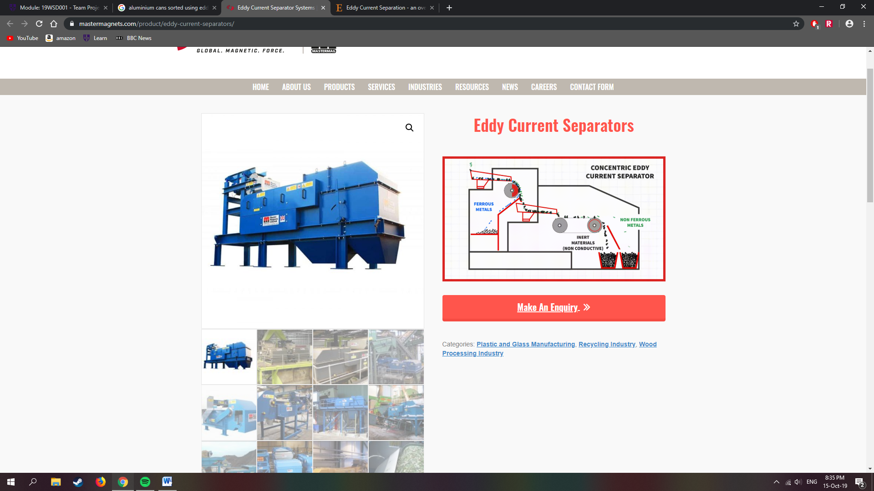

* Portable emission spectroscopy analysers[4]

Steel

* Separated using electromagnets
* So, for 99% of the trash we generate… just sort out the metal from non-metal. Easy enough, since metals are denser than plastic, paper and glass. Run the metal scrap under a magnet. If it comes up, it's steel. If it doesn't, it's aluminum.[5]

1. <https://edu.rsc.org/section/feature/the-science-of-sorting/2000131.article>
2. <https://en.wikipedia.org/wiki/Drink_can>
3. <https://www.azom.com/article.aspx?ArticleID=1446>
4. <https://www.spectro.com/products/xrf-spectrometer/xsort-xrf-gun-handheld-analyzer>
5. <https://www.quora.com/How-can-steel-be-separated-from-aluminium>